Simeon Patton

OSU CS362 – Spring 2021

Extra credit assignment

Unittest and Pytest on two programs and user stories for the social media platform.

The repo for this assignment can be found at:

<https://github.com/pattons-OSU/CS362_ExtraCredit>

1. Write a program that reverses a sentence and then write tests in both unittest and pytest.
2. As seen below, the program takes input from the user and outputs the sentence in reverse WORD format.

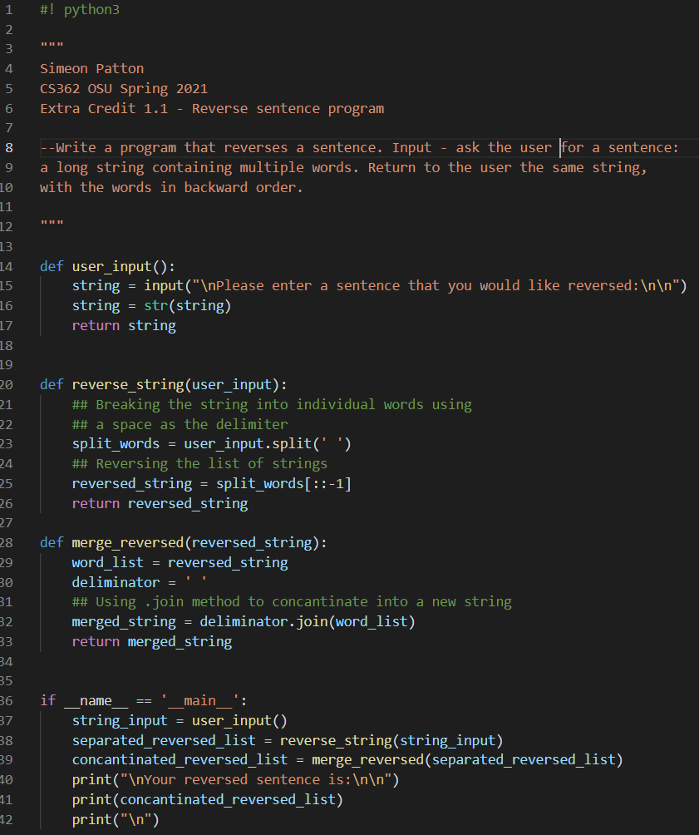

1. Unittest Code and Output for reverse sentence

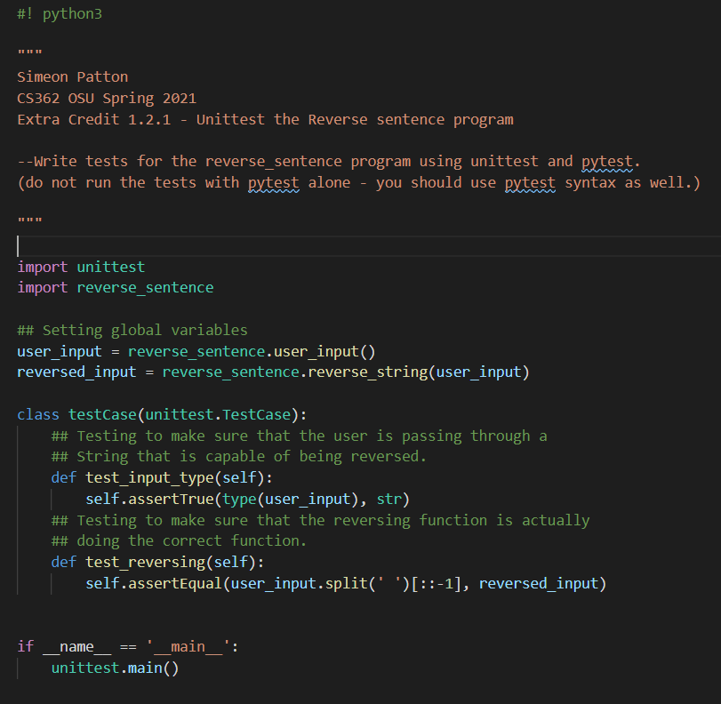

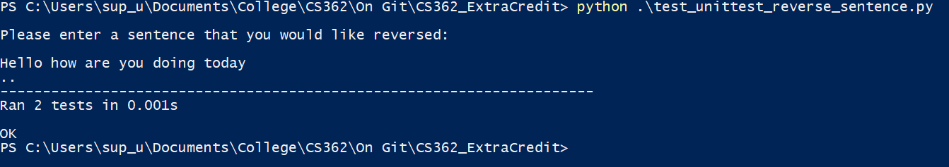

1. Pytest Code and output for reverse sentence

***Had to use the “-s” flag to capture user input

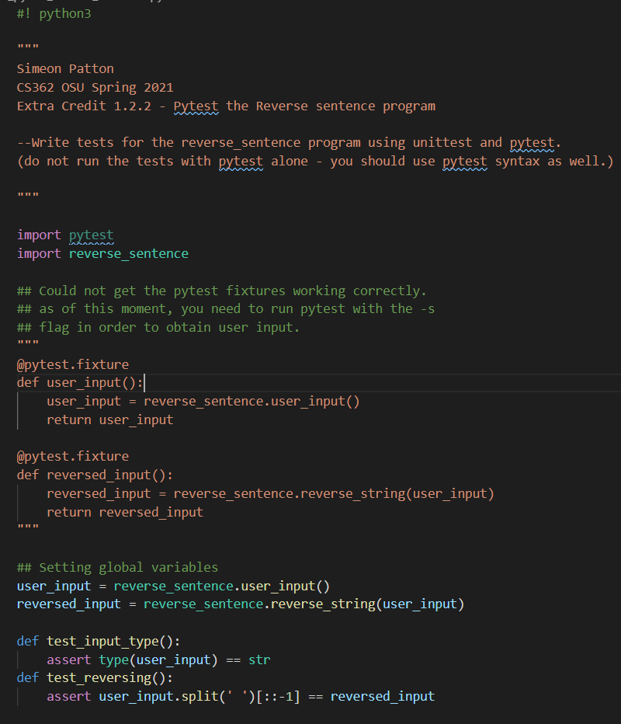

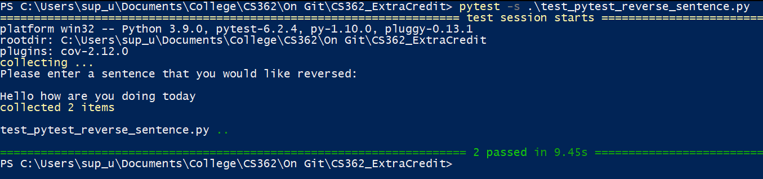

1. Question 2:

Five user stories from the social media platform in assignment 1;

* As a user I want to be able to post updates to a friend viewable wall in order to share my experiences.
* As a user I want to be able to message other users in order to keep in touch.
* As a user I would like to upload my photos to share them with friends and family.
* As a user I would like to organize my photos into specific albums in order to group like ideas.
* As a user I would like to be notified when another user sends me a message through the messaging system.

1. Question 3:

Write a program that takes in a target sum and array of values and determines the pair of values that reaches the target sum. Then write unittest and pytest programs for it.

1. 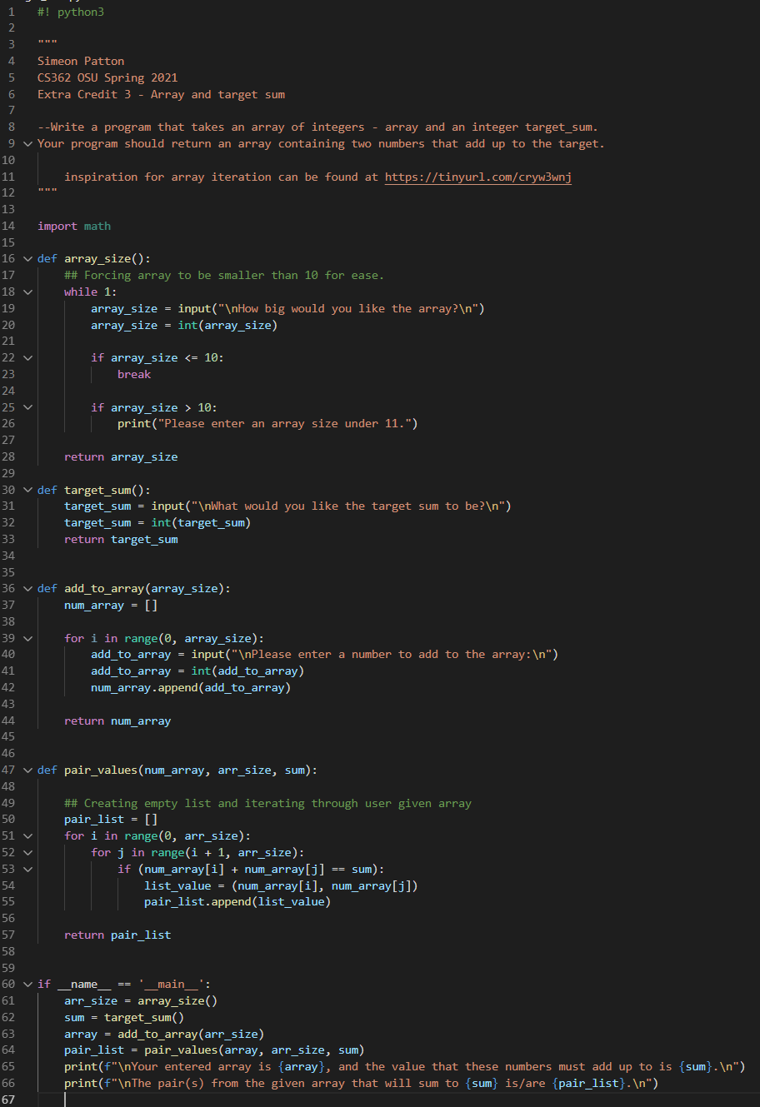Target_sum.py program
2. Unittest code and output;

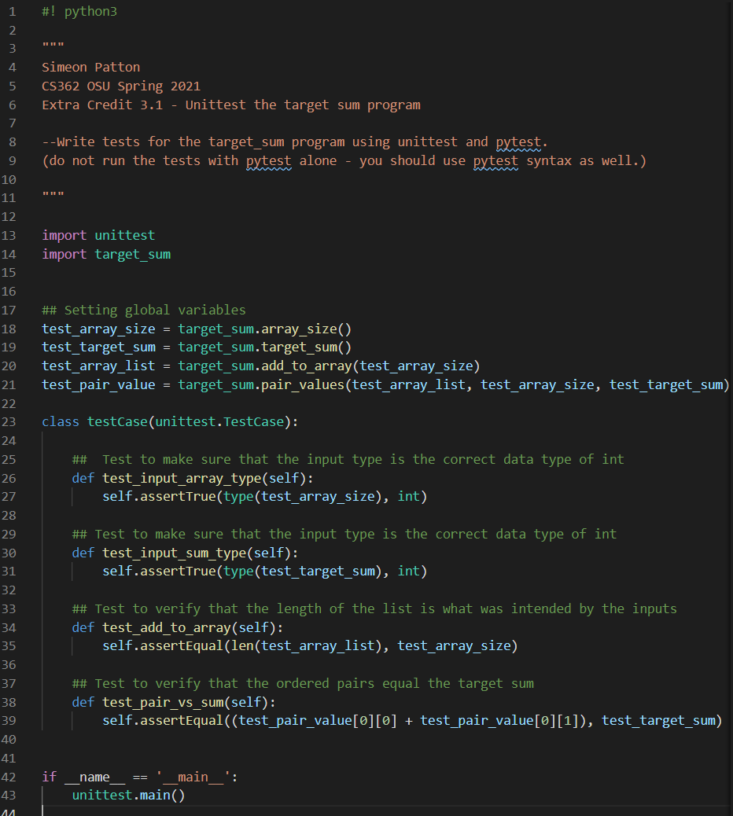

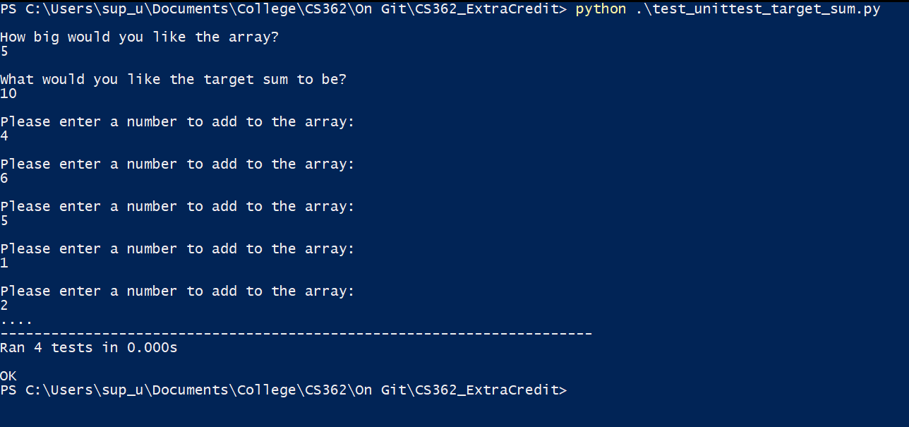

1. Pytest code and output;

***Had to use the “-s” flag to capture user input

